The Analysis of Sweden
Marketing mix

Group4

S1163008 Annie Ho
S1163012 Erica Chuang
S1163024 Mita Dai
S1163039 Jessie Gu
S1163052 York Kuo

Table of contents

Introduction 2
Objectives 2
STP 2
Segmentation 2
Targeting 3
Positioning 4
Product 6
Pricing 7
Promotion 8
3P 9
People 9
Process 10
Physical 10
Conclusion 11

Introduction
Husband: "Hey, honey, do we have any hand tools at home to assemble our new furniture?" Wife: "Yes, I'll look for it, I don't know where it is." After a long search, wife: "All I found was this, a screwdriver." This is a very embarrassing situation. According to the previous report, in Sweden, due to the influence of living habits, people often need to make things by themselves, such as assembling furniture, simple car repairs, and even small-scale house repairs. But when they prepare the materials, they find that they can't find the tools, or even though they have found the tools, there are only a few tools to use. Therefore, our product, the smart tool box set, can come in handy. On the one hand, it can solve the problem of not being able to find the tools. On the other hand, it can solve the problem of insufficient tools. In this report we will analyze STP, then we will mention product positioning, marketing mix, distribution channels, and pricing strategy in 4Ps, and then we will discuss People, Process and Physical evidence in 3Ps to complete our Marketing plan.

Objectives
In this report, we will:
- Use our STP analysis to understand Sweden market segments, target markets and position our products.
- Introduce the functions of our products and use the data we analyze to design our products to meet customer needs.
- Pricing Strategy Based on Our Product Features and Swedish revenue situation.
- Describe the various channels that can be utilized for our products, along with strategies to engage and excite customers identify the various relationships, potential problems, and detailed information throughout the business process.

STP
Segmentation
- Geographic:
In terms of geographics, we divide Sweden into three parts based on population density: high-density population, medium-density population, and low-density population.
- Demographic:
In terms of demographic, we chose age and family type for our segmentation. We divide age into 4 parts: elderly, middle-aged, early adulthood, and adolescence. In terms of family types, we also categorize them into nuclear family, single-parent family, grandparent family, childless family, extended family, and stepfamily.
- Psychographic:
In terms of psychographics, we divide it into several parts: whether this tool is a professional tool or a casual tool, whether it is easy to use or hard to use, whether it is intelligent or non-intelligent, and whether it is exquisite or not exquisite.

Targeting
Figure 1 Population density of Sweden geography
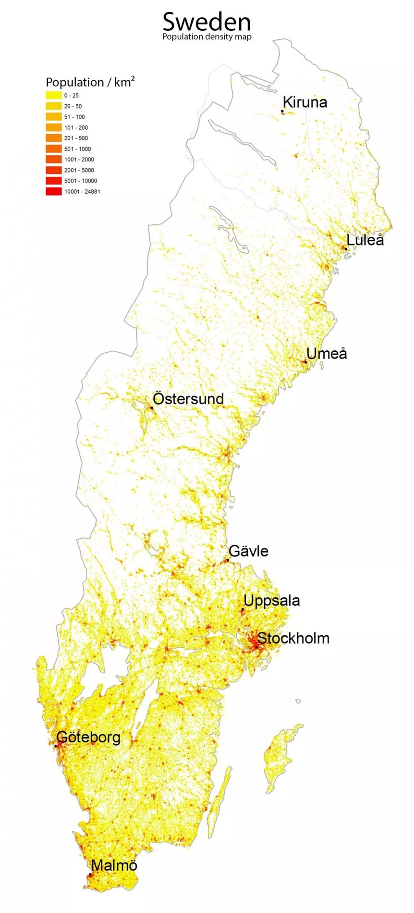
In Sweden, the population is mostly concentrated in the southern part. According to Figure 1, we can see that the population is concentrated in Stockholm in the southwest. Therefore, we have chosen the high population density southwest region as our target.
As for the age aspect, we have chosen middle-aged and young adults as our target customers because these age groups are most likely to collaborate with family members in assembling or repairing furniture. Regarding family types, we have selected nuclear family, extended family, and stepfamily as our target customers. An easy-to-use tool would be more suitable for families to assemble furniture together during weekends.
In terms of customer behavior, our target audience is those who enjoy unique and innovative items. They are open to and willing to try new high-tech products. We have also observed that Swedish families enjoy DIY repairs and assembly. However, with the clutter of a typical toolbox, they may struggle to find the specific tool they need, potentially delaying their furniture repair
progress.

Positioning
Our hand tool product positioning includes the following features:
- Midlife and early adulthood:
Our products are particularly suitable for consumers in middle age and early adulthood. These people are often at a critical stage in their careers and have a higher need for high-quality, practical tools.
- Various family types and members:
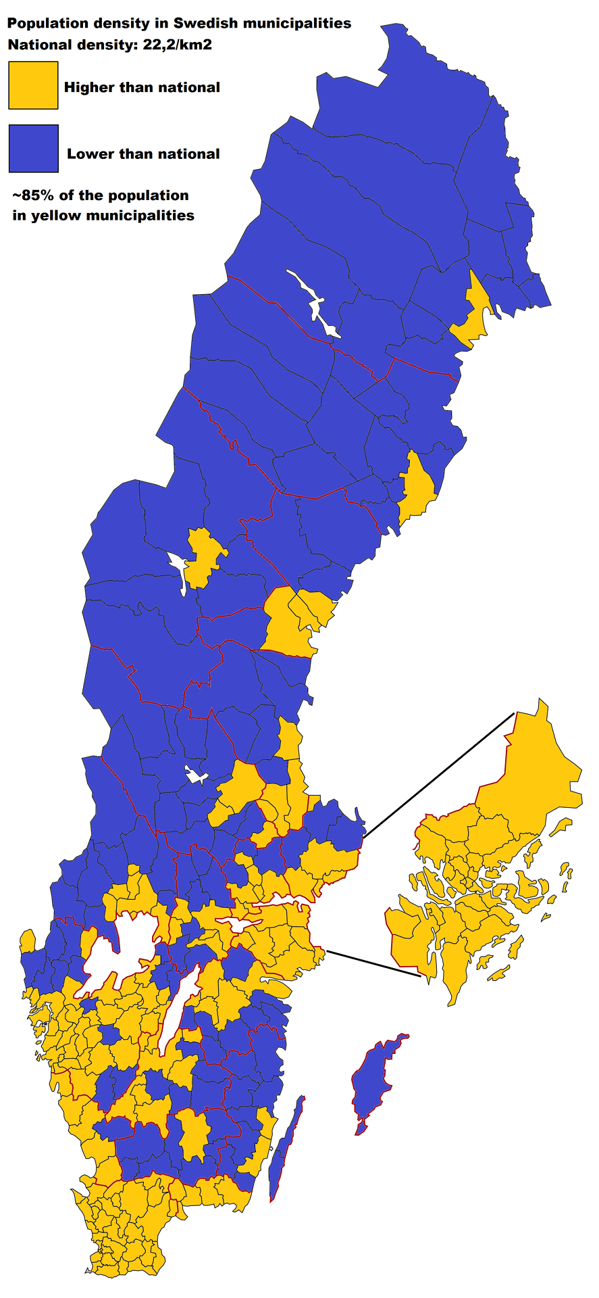
Whether it's a single person, a couple, or a family with children, our hand tools can meet their needs. Our tools are not only suitable for home repairs but also for DIY enthusiasts.
- Areas with high population density (southeast):
Figure2 sweden population density map
We focus on areas with high population density, such as southeastern Sweden Figure2, where consumers have greater purchasing power and a higher demand for innovative and high-quality products.
- Casual look:
Our tools are designed to be simple, modern, and attractive, suitable for a variety of usage scenarios. From daily home repairs to outdoor activities, our products are not only functional but also stylish, catering to consumers with different lifestyles.

KING TONY (Figure 3): The tool box is designed with tenons for more convenient storage. The hand tool, made of stainless steel, includes a buffer device on the handle, making it ideal for home use. | 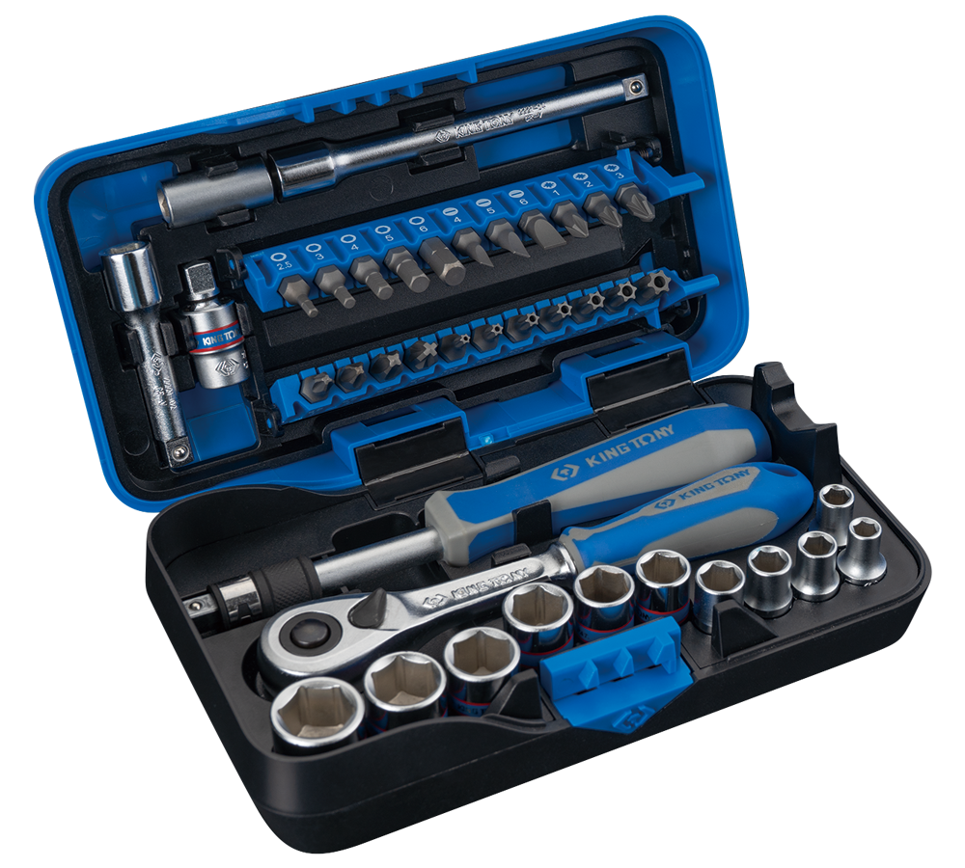Figure3
TENGTOOLS (Figure 4): The plastic tool box has a lock design, a reinforced structural design, a telescopic handle, and an anti-slip rubber pad on the bottom of the box. The hand tools are not equipped with a buffer device, making them more suitable for professionals. | 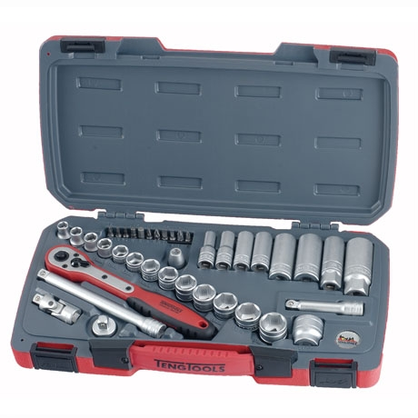Figure4
KINGSDALE (Figure 5): Hand tools are packaged in plastic boxes. These tools feature stainless steel construction, with handles designed without extra labor-saving mechanisms,making it more suitable for professionals. | 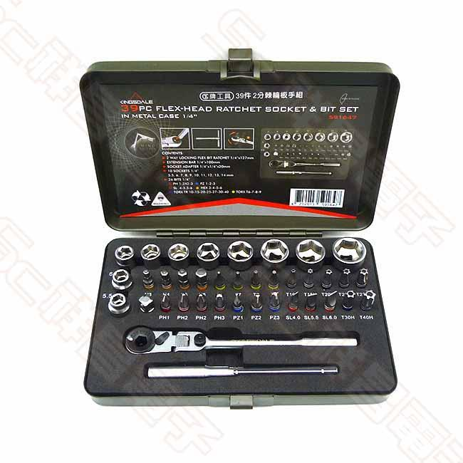Figure5
DNA Motoring Tools (Figure 6): The plastic tool box and the handle are cushioned and will not hurt your hands. They are more suitable for home use. | 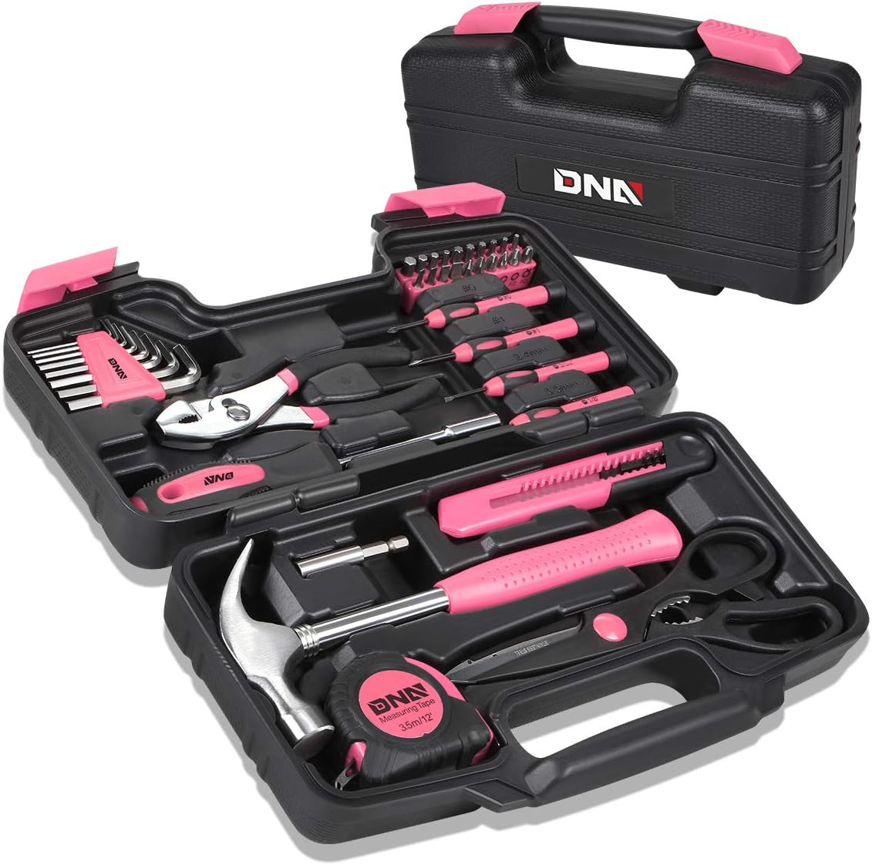  Figure6
Product
Based on our analysis, we think that the first thing to solve was the problem of insufficient tools, so we decided to launch an entire toolbox set instead of a single tool. As for the material of the tool, we chose to use S2 (Shock-resistant, S-type). Compared with Cr-V, a common material, S2 is more durable. Although the cost increase will be reflected in the selling price, it is still in line with our pricing strategy. Regarding the number of tools, after we analyzed the existing specifications on the market, we believe that 39 pieces (Figure 7) are a suitable quantity for general daily repairs.
Now comes the second question, what if people often can’t find tools? We see the answer from Apple's product AirPods Pro series. If headphones can use a connection to a phone to emit sound and position, why not a hand tool? We will design a dedicated search app, just like the search function of the iPhone. We want to install a micro sounder and Bluetooth connector (Figure 8) on the tool. This Bluetooth connector can help us locate the position of the tool after we connect the mobile phone to the hand tool and can be used with a dedicated App to emit sound. This way you don’t have to worry about losing your tools.
As for battery life, we plan to use a micro-battery similar to a Bluetooth headset. The question is, how do we charge the battery of hand tools? Our solution is to treat the entire toolbox as a charging compartment, which will be equipped with a medium-sized battery.
Usually, we only need to charge the toolbox with a charging cable (Type C specification), then put the tools in and use the magnetic charging function to complete charging. The battery of the toolbox can last for more than 3 months on a single charge.
Our tools also provide customers with customized services for an additional fee. They can choose whether to add foam (Figure 9) to the handle of the tool. This foam makes customers more comfortable when using hand tools. In addition, we also provide laser engraving services. Customers can provide the text or patterns they want to be engraved on, and we can help them customize it.

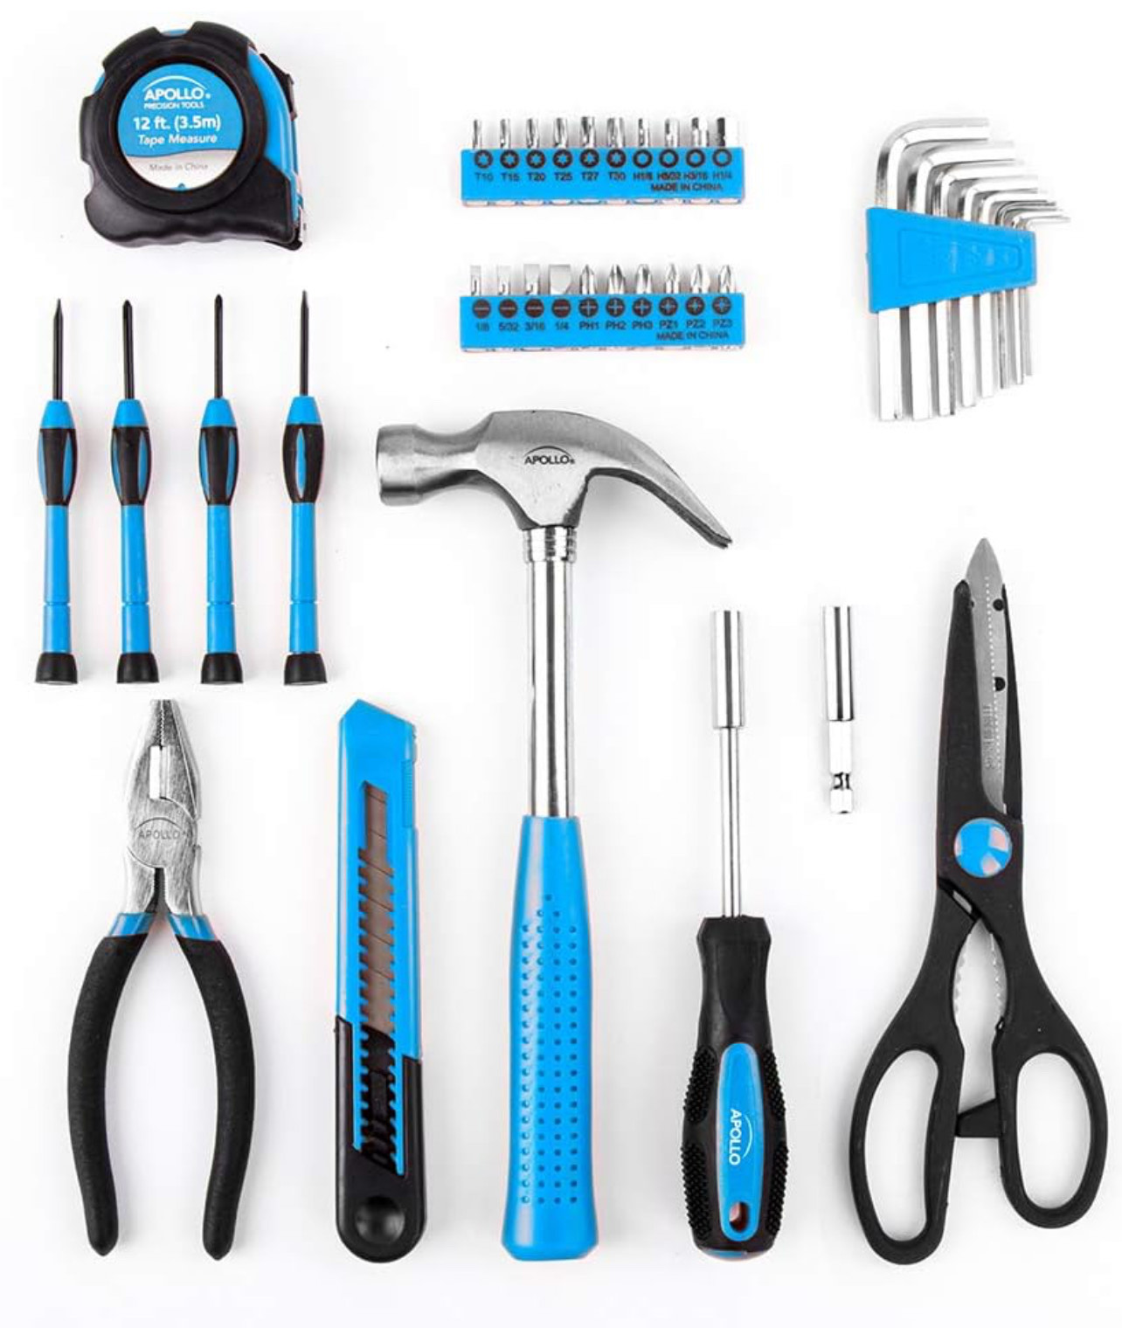 |  | 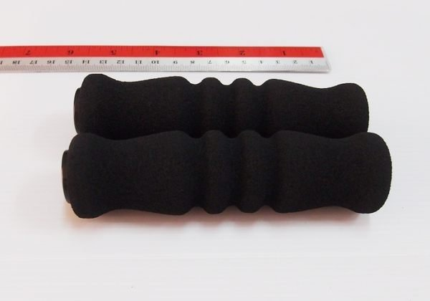
39 pieces (Figure 7) | Bluetooth (Figure 8) | Foam (Figure 9)

Pricing
We have chosen a market-skimming pricing strategy because we believe our hand tool products are more competitive than other brands in terms of functionality. We provide customized services and provide the text or patterns they want to engrave. In addition, Our products have a positioning function and can be connected to a mobile phone holder, allowing consumers to quickly locate the tool. Based on this feature, we decided to adopt this pricing strategy. As the first company to combine Bluetooth technology with hand tools, our starting price is higher. Many people are troubled by the frequent disappearance of hand tools. Rather than constantly buying new tools, it is more beneficial to buy tools that are ready to be positioned. Although our products are more expensive than regular hand tools, they last longer. Although the initial cost is higher, in the long run, consumers save themselves the hassle and cost of frequently replacing tools. Secondly, if we set the price very low from the beginning, we will have no room to lower the price in the face of new competitors, and we will not have the leverage to adjust the price according to market changes. A high price is often seen as a sign of high quality, especially because of the advanced technology used in our products. Pricing our products too low will make it difficult to cover manufacturing costs and maintain profitability. Our research shows that the price range for a 39-piece hand tool box is mainly between 300 and 1,600 SEK , while the per capita income in Sweden is approximately 27,000 to 29,000 SEK . With this in mind, we decided to price the product at 1,600 SEK , in line with the market skimming pricing strategy. This price not only reflects the value of our products, but also provides room for future price adjustments.

Promotion
channels - physical & online stores
The main sales channels which are located in Sweden are physical retail stores and e-commerce, so we choose to distribute our products via these two channels. The Swedish retail industry meets the needs of different consumers, including, but not limited to Clas Ohlson, IKEA. And similar to many other countries globally, Sweden's e-commerce market has seen significant growth over the past decade. Many consumers in Sweden have developed a routine of purchasing items online. Because of the above reasons, we choose to sell our products in the following channels.
- Clas Ohlson
Founded in 1918 as a mail-order business in Sweden, Clas Ohlson has evolved into a retail company serving customers in three markets today. They are committed to creating available, sustainable and enjoyable home fixing with attractive prices for everyone. Clas Ohlson is a very well-known and trusted retailer in Sweden, and its long history and good reputation can help increase the credibility and appeal of our brand if our products can be sold here. In addition, it also provides a broad market for our hand tool brand.
- Amazon.se (Online shopping website)
Choosing to sell a hand tool brand on Amazon Sweden offers several significant benefits. First, the Amazon website has a large number of active users, enabling our products to reach a vast base of potential customers. Utilizing it can help our brand enter the market swiftly and enhance brand awareness. In addition, Amazon is a trusted and well-known shopping platform. Consumers generally have a high level of trust in shopping on Amazon, which helps increase sales conversion rates. Utilizing Amazon can instill a greater sense of trust in our products among customers, thereby boosting the likelihood of purchases.

Strategy- Combining push marketing and pull marketing strategies
Push marketing is a strategy that actively advertises and promotes products or services to potential customers. For our hand tool brand, this can include methods such as advertising, promotional activities, direct marketing, and emails. The primary goal is to spark customers' interest, encouraging them to make a purchase. Through the push marketing strategy, we can promote our products more effectively and increase the sales rate of the products. Pull marketing strategy is a better way to attract potential customers who voluntarily seek information about products or services. The clearest example is SEO, where customers search for specific keywords and naturally find their way to our website. Due to the respective advantages of the two marketing strategies mentioned above, we have decided to combine them to enhance the comprehensiveness of our product marketing. We can start by using advertising to promote our hand tools and emphasize their product features. When someone searches our brand's official website out of curiosity, this transition represents a shift from push marketing to pull marketing.

3P
People
The relationships we meet throughout our business, including:
- Manufacturing Workers
Because our products include many customized components, to reduce manufacturing errors, we will establish SOPs for new employees and conduct regular employee training. Additionally, to ensure a safe working environment for manufacturing workers, we should conduct periodic inspections of the factory environment.
- Suppliers
To provide stable and high-quality products to customers, it's important to maintain a good relationship with suppliers. Regularly updating contracts helps to safeguard mutual interests and build a positive reputation in the market, not only fostering good relations with suppliers but also enhancing credibility with customers.
- Customers
To retain existing customers and attract new ones, our main sales goals include offering warranty services and establishing a membership system where frequent buyers enjoy more benefits than others. To attract new customers, we offer first-time purchase discounts.
- Customers Service Staff
For effective communication in customized services, it's crucial to train customer service staff with SOPs to handle customer inquiries correctly and conduct regular training sessions to keep them updated. This ensures a seamless interaction between our business and customers.
- Partners
Our products are available through retail channels like Clas Ohlson and our official online shopping website. Retail sales staff should have a thorough understanding of our products. Customers can access additional information and contact customer service through our official website or QR codes. It's crucial to partner with a reliable internet company to ensure robust server setup and protect customer personal information on our website.
Process
The problems that the customers may face in the process of receiving the product:
- Due to customization, the waiting time might be too long for customers.→In order to solve this problem, when customers place orders, the system calculates the total customization time plus logistics time to estimate the expected arrival time.
- Products damaged or lost during shipping.→To address these concerns, we collaborate with a logistics company. Customers can track their shipment online to monitor its location. In case of damage or loss, they can contact customer service for refunds or product replacements. We also utilize email to send shipment updates to customers.
- Because our products must be shipped via sea freight or air freight, logistics times can be lengthy. →To cater to customers who wish to receive their products faster, they can freely choose between air freight or sea freight, considering shipping costs and time. We also partner with specific air freight or sea freight companies, ensuring reliable shipping services.
Physical evidence
The comprehensive product information that we can offer to our potential customers. Firstly, our hand tools come with reliable certifications:
- CE marking
Sweden is a country in the European Union, so it is necessary for products exported to the EU to undergo CE certification. Having a CE certification guarantees our products have been evaluated to comply with stringent safety, health, and environmental standards. In addition, it is a commitment from enterprises to consumers, which increases consumers' trust in products and reduces the risks of selling in the European market.
- DIN and ANSI standards
Although DIN and ANSI standards are not mandatory for the Swedish market, complying with these standards can provide the following benefits. The first is to enhance product competitiveness. Complying with international standards can enhance the competitiveness and global recognition of our hand tool brands in the global market. The second is to enhance consumer trust. Standardized product quality can enhance consumer trust in tools. Therefore, it is not only a commitment to our customers but also a standard we set for ourselves to ensure high-quality products.

Next, we adopt different approaches to showcase our product across physical and online channels:
- Physical retail stores
When displaying hand tool products in a physical channel, we can use the following methods to attract customers' attention and demonstrate the features of the products. First, install dedicated display stands that categorize and arrange the hand tools by type or use, making it easy for customers to find what they need and inspect the products in person. Second, live demonstrations. Have trained staff perform live demonstrations of the hand tools in-store, showing their use and highlighting their advantages. Last but not least, we provide a product catalog showcasing a variety of customization options for hand tools to help customers easily understand our products.
- Online shopping website
Because online shopping lacks the ability to physically touch or see products in person, we will offer 3D models on our website. This will allow customers to freely rotate and closely examine every detail of the product online. In addition, provide a comprehensive product description along with the product's technical specifications and dimensions to ensure that customers have a clear understanding of the specific parameters of the product. By utilizing these strategies, we can significantly enhance the online presentation of hand tools, attract more customers, and boost sales opportunities.

Conclusion
In conclusion, we are targeting the high population density southwest region, particularly Stockholm. Our target customers are middle-aged and young adults in nuclear, extended, and stepfamilies, who appreciate unique, innovative, and high-tech products. An easy-to-use tool would be beneficial for their DIY projects.
Our products are very different from those on the market. In order to solve the problem of insufficient tools, we decided to sell tool box sets. In order to solve the problem of not being able to find the tool, we added a small speaker and a Bluetooth connector to the tool to connect to the mobile phone. After being connected, it can be combined with the App we designed to make the tool make sounds and even locate it. However, this is why our products are priced at a high price. We have adopted a high-price strategy for our products, leveraging their unique and advanced features such as positioning functions and Bluetooth connectivity. This aligns with our market skimming approach, targeting Sweden's high consumption level and demand for premium, technologically integrated tools. This strategy ensures we meet market expectations while maximizing revenue.
From our 3Ps, customers can know they can get our products easily. And also, customers can be assured of stable supply and reliable logistics. We maintain high quality and utility in our products. Additionally, product certifications help customers recognize the excellence and value of our offerings. If we leave a positive impression, customers are likely to return, strengthening our product's competitiveness.

Population map of Sweden.swedenmap360.com
map on web.sweden population density map. zoom-maps.com
KING TONY .kingtonylearn.com
YENG TOOLS.tengtools.com
sciket.KINGSDALE.sciket.com
DNA Motoring Tools. walmart.com
Apollo Tools original 39 delar. www.amazon.se
Bluetooth. zh.wikipedia
Foam. tw.bid.yahoo.com
statista.2024.Retail industry in Sweden - statistics & facts
Clas Ohlson.clasohlson.com
push marketing vs pull marketing.https://cool-das.com/
European Commission.ce-marking

